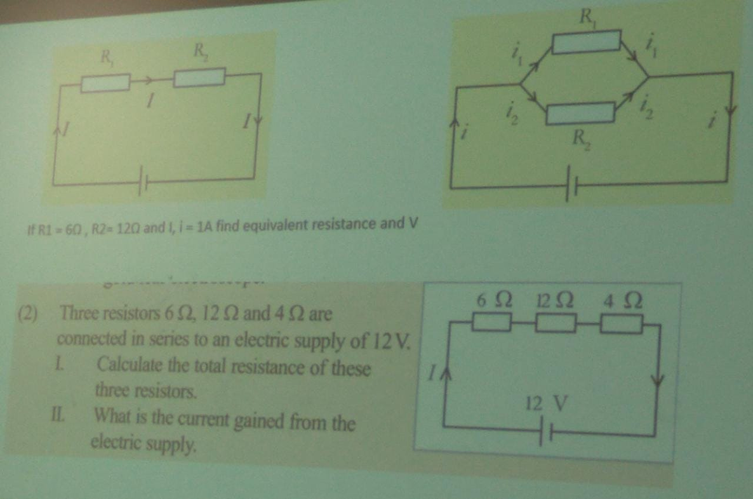

1. A circuit has a resistance of 10 ohms and a current of 2 amperes. What is the voltage across the circuit?

2. If a power supply provides a voltage of 12 volts and the circuit has a resistance of 4 ohms, what is the current flowing through the circuit?

3. A light bulb has a resistance of 50 ohms and operates at a voltage of 120 volts. How much current does is draw?

4. A circuit has a current of 5 amperes and a voltage of 20 volts. What is the resistance of the circuit?

5. A resistor dissipates power at a rate of 12 watts when a current of 2 amperes passes through it. What is the resistance of the resistor?

6. A circuit has a resistance of 8 ohms and draws a current of 3 amperes. What is the power dissipated by the circuit?

7. A power supply delivers a current of 2 amperes to a circuit with a resistance of 15 ohms. What is the power supplied by the sources?

8. A device operates at a power of 60 watts and has a voltage of 120 volts. What is the current consumed by the device?

Answers

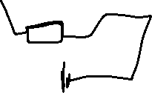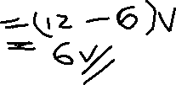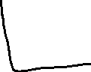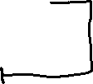

01

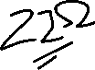

02.

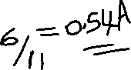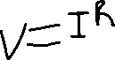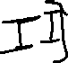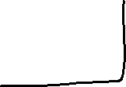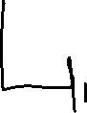

01. 10 ohms , 2A

|  |
| --- |
| V=IR  = 2* 10  = 20V |

02. 12V , 4 ohms

|  |
| --- |
| V=IR  12 = I* 4  = 3A |

03. 50 ohms, 120V

|  |
| --- |
| V=IR  120 = I* 50  12/5 = I  2.4A= I |

04. 5A, 20V

|  |
| --- |
| V=IR  20 = 5* R  R = 4 ohms |

05. 2A, 12W

|  |
| --- |
| P=VI  P=V2/R  P=I2R  P=I2R  12=22*R  12=4*R  R = 3A |

06. 8 ohms, 3A

|  |
| --- |
| P=I2R  =9*8  = 72 W |

07. 15 ohms, 2A

|  |
| --- |
| P=I2R  = 4*15  = 60W |

08. 60W ,120V

|  |
| --- |
| P=VI  60=120I  6/12=I  I = 0.5A |